SDN Lab Report: Four Controller Applications on Mininet

Test environment
- Emulator: Mininet with Open vSwitch 3.3.9, OpenFlow 1.3
- Controllers: ONOS 2.7.0 (Tasks 1 and 4), os-ken 4.2.2, the maintained fork of Ryu (Task 2), none for Task 3 (flows pushed with ovs-ofctl)
- Language: Python 3.13 with the request’s library
- Host: Linux cloud container. It has no Open vSwitch kernel module, so OVS ran in its userspace datapath (MN_USERSPACE=1). A normal Mininet VM uses the kernel datapath and needs no such setting.

Task 1: Automated network policy engine
Scenario: continuously check the controller and block high-bandwidth consumers during peak hours.
Implementation: task1/policy_engine.py uses requests against the ONOS northbound REST API. It reads devices (GET), parses port statistics from the JSON response and POSTs an ICMP drop rule between 10.0.0.1 and 10.0.0.2 when a port exceeds the threshold.

Pseudocode
CONST ONOS = "http://<controller>:8181/onos/v1", AUTH = (user, password)
INPUT src_ip, dst_ip, threshold_Bps, peak_start, peak_end, interval

blocked <- {}
LOOP every <interval> seconds:
devices <- HTTP GET ONOS/devices # JSON
switches <- [d.id FOR d IN devices.devices IF d.available]
stats <- HTTP GET ONOS/statistics/delta/ports # JSON
FOR EACH dev IN stats.statistics:
FOR EACH p IN dev.ports:
rate <- max(p.bytesReceived, p.bytesSent) / p.durationSec
IF rate > threshold_Bps
AND peak_start <= now.hour < peak_end
AND dev NOT IN blocked:
FOR (s, d) IN [(src_ip, dst_ip), (dst_ip, src_ip)]:
flow <- { priority: 40000, isPermanent: true, deviceId: dev,
selector: { ETH_TYPE = 0x0800, IP_PROTO = 1,
IPV4_SRC = s/32, IPV4_DST = d/32 },
treatment: { instructions: [] } } # empty = DROP
HTTP POST ONOS/flows/<dev>?appId=policy body = flow
ADD dev TO blocked

Output
Command: sudo MN_USERSPACE=1 python3 task1/task1_topo.py (ONOS fwd app active)
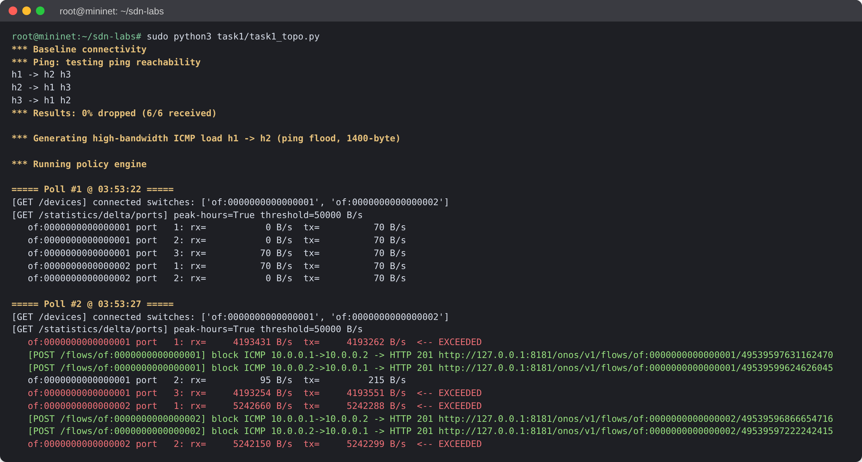
Figure 1.1: Device discovery, port statistics, and threshold breach with POST /flows (HTTP 201)
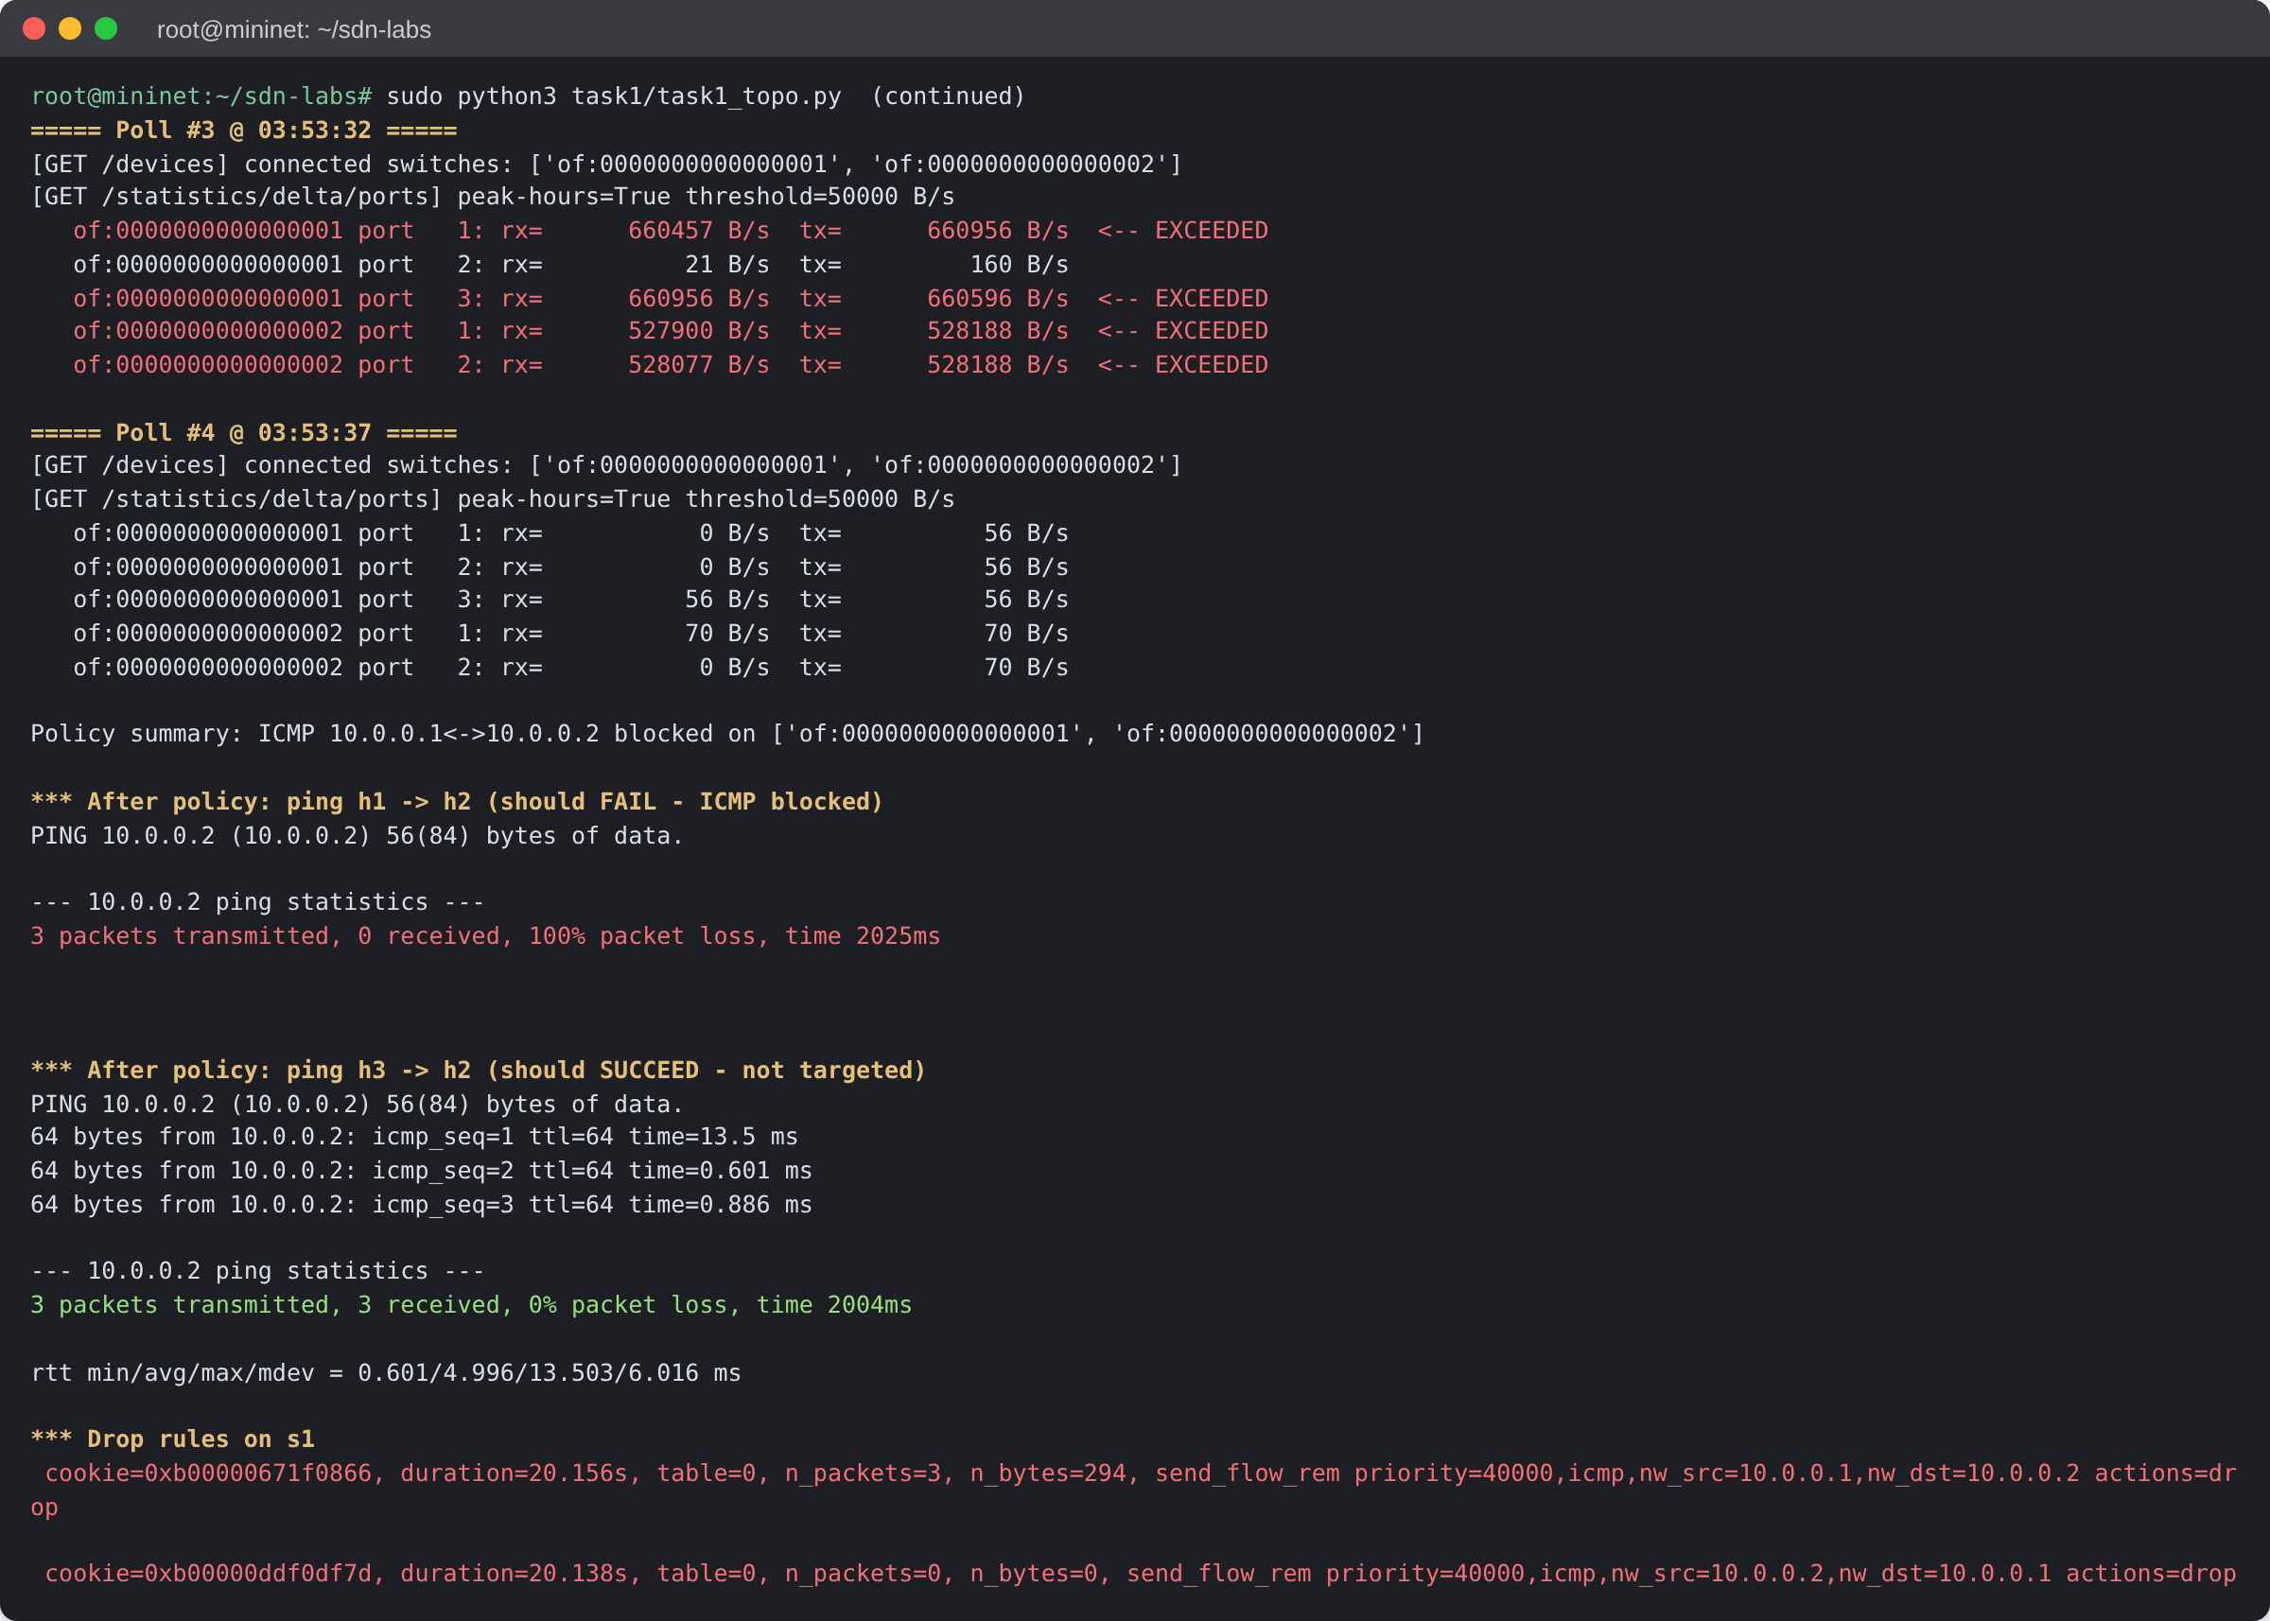
Figure 1.2: Policy result: h1→h2 ICMP blocked, h3→h2 unaffected, drop rules on s1

Result
- Poll #2 detected about 4–5 MB/s of ICMP flood traffic, above the 50 KB/s threshold.
- Four drop rules were installed through POST /flows, each returning HTTP 201 Created.
- After the rules were installed, ping h1→h2 had 100% loss while ping h3→h2 had 0% loss, so only the targeted pair was blocked.

Task 2: Broadcast-storm prevention with MAC learning
Scenario: prevent broadcast storms caused by topology loops.
Implementation: task2/loop_safe_switch.py is an os-ken (Ryu API) application, tested on a three-switch triangle topology that forms a physical loop.

Pseudocode
mac_to_port <- {} # dpid -> { mac -> port }
bcast_seen <- {} # (dpid, src_mac) -> (first_in_port, timestamp)

ON SwitchFeatures(dp):
install FlowMod(priority 0, match ANY, action OUTPUT:CONTROLLER) # table-miss

ON PacketIn(dp, in_port, data):
eth <- parse_ethernet(data) # eth.type, eth.src (src_mac), eth.dst (dst_mac)
IF eth.type IN {LLDP, IPv6}: RETURN

IF eth.dst == ff:ff:ff:ff:ff:ff: # broadcast loop guard
rec <- bcast_seen[(dp.id, eth.src)]
IF rec is NONE OR rec expired (30 s):
bcast_seen[(dp.id, eth.src)] <- (in_port, now)
ELSE IF rec.first_in_port != in_port: # looped copy
install FlowMod(priority 100,
match {in_port, eth_src = eth.src, eth_dst = broadcast},
actions = [] /* DROP */, idle_timeout 60)
RETURN

mac_to_port[dp.id][eth.src] <- in_port # source MAC learning
IF eth.dst IN mac_to_port[dp.id]: # destination lookup
out <- mac_to_port[dp.id][eth.dst]
install FlowMod(priority 10, match {in_port, eth_src, eth_dst}, OUTPUT:out)
ELSE:
out <- FLOOD # unknown destination
send PacketOut(dp, in_port, OUTPUT:out, data)

Output
Commands: python3 run_osken.py task2/loop_safe_switch.py 6633 and sudo MN_USERSPACE=1 python3 task2/loop_topo.py
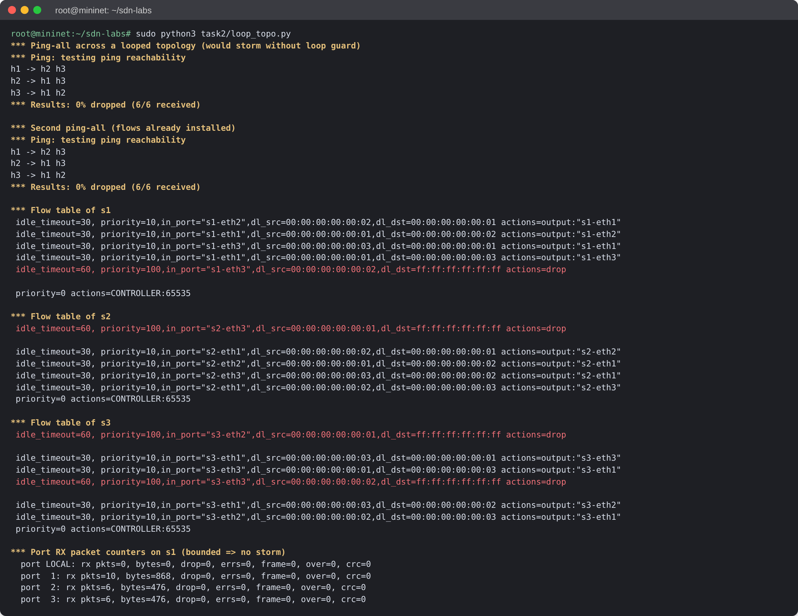
Figure 2.1: Mininet: ping-all over the looped topology and resulting flow tables (learned and DROP rules)
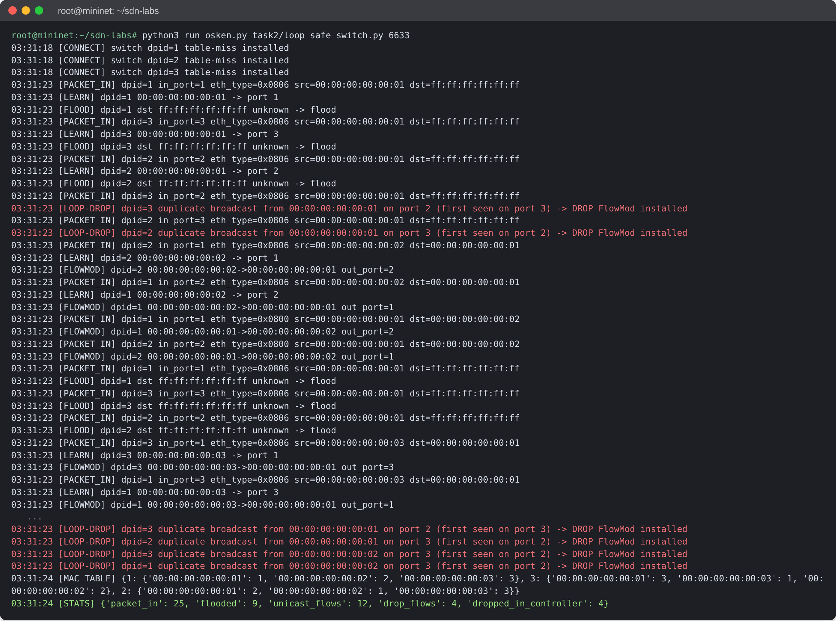
Figure 2.2: Controller log: PacketIn parsing, MAC learning, flooding, FlowMods, and loop-drop decisions

Result
- Ping-all succeeded with 0% loss on a topology that contains a loop.
- The controller received only 25 PacketIn events in total, so no broadcast storm formed.
- Four reactive DROP FlowMods (priority 100) removed the looped broadcast copies.
- Twelve unicast forwarding FlowMods were installed from the MAC learning table.

Task 3: 5G campus network slicing with QoS queues
Scenario: two isolated slices share one OpenFlow switch. Slice A carries streaming video and Slice B carries control signalling.
Implementation: task3/slice_qos.sh holds the ovs-vsctl and ovs-ofctl commands. task3/slice_topo.py runs the Mininet test and generates traffic with iperf3.

Pseudocode
FOR EACH egress port P on the switch:
create QoS(type = linux-htb, max-rate = 100 Mb/s) on P with queues:
Q0 default : min 1 Mb/s, max 100 Mb/s
Q1 Slice A (stream) : min 40 Mb/s, max 80 Mb/s
Q2 Slice B (control): min 5 Mb/s, max 10 Mb/s

install flows on the bridge:
priority 200, ip, ip_dscp = 34 (AF41) -> set_queue:1, NORMAL # Slice A
priority 200, dl_vlan = 100 -> set_queue:1, NORMAL # Slice A
priority 200, ip, ip_dscp = 46 (EF) -> set_queue:2, NORMAL # Slice B
priority 200, dl_vlan = 200 -> set_queue:2, NORMAL # Slice B
priority 0 -> set_queue:0, NORMAL # default

VERIFY: send iperf3 UDP per slice with ToS = DSCP << 2;
read per-queue rates and HTB class counters (tc -s class show dev P)

OVS commands
ovs-vsctl -- set port s1-eth3 qos=@newqos \
-- --id=@newqos create qos type=linux-htb other-config:max-rate=100000000 \
queues:0=@q0 queues:1=@q1 queues:2=@q2 \
-- --id=@q0 create queue other-config:min-rate=1000000 other-config:max-rate=100000000 \
-- --id=@q1 create queue other-config:min-rate=40000000 other-config:max-rate=80000000 \
-- --id=@q2 create queue other-config:min-rate=5000000 other-config:max-rate=10000000

ovs-ofctl -O OpenFlow13 add-flow s1 "priority=200,ip,ip_dscp=34,actions=set_queue:1,normal"
ovs-ofctl -O OpenFlow13 add-flow s1 "priority=200,dl_vlan=100,actions=set_queue:1,normal"
ovs-ofctl -O OpenFlow13 add-flow s1 "priority=200,ip,ip_dscp=46,actions=set_queue:2,normal"
ovs-ofctl -O OpenFlow13 add-flow s1 "priority=200,dl_vlan=200,actions=set_queue:2,normal"
ovs-ofctl -O OpenFlow13 add-flow s1 "priority=0,actions=set_queue:0,normal"

Output
Command: sudo MN_USERSPACE=1 python3 task3/slice_topo.py
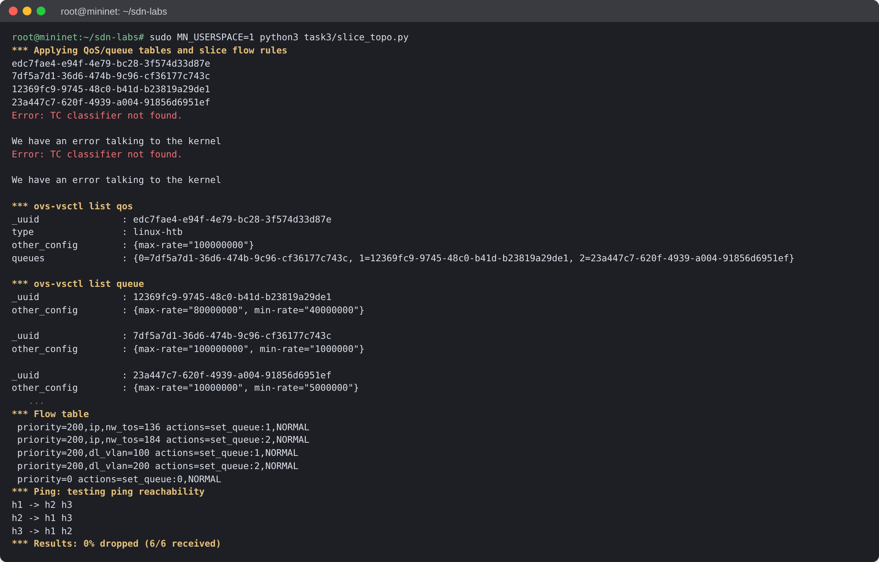
Figure 3.1: QoS and Queue tables created on egress port s1-eth3, plus the slice flow rules
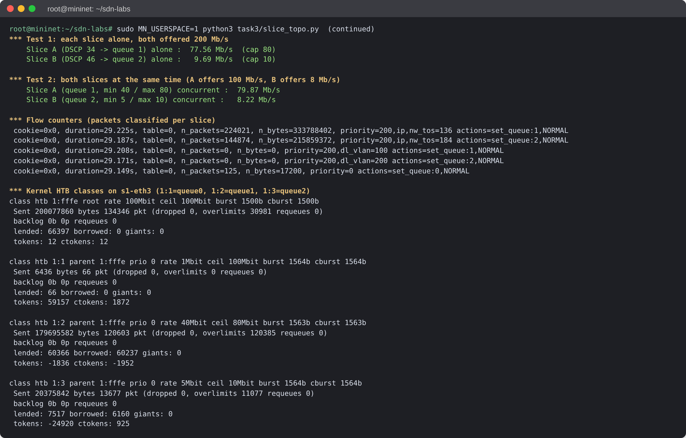
Figure 3.2: Measured slice rates, per-slice flow counters, and kernel HTB queue counters

Result
- Each slice alone, offered 200 Mb/s: Slice A reached 77.6 Mb/s (cap 80) and Slice B 9.7 Mb/s (cap 10).
- Both slices at once: Slice A reached 79.9 Mb/s and Slice B 8.2 Mb/s, and the HTB counters show traffic in queue 1 (class 1:2) and queue 2 (class 1:3).
- Container notes: the userspace datapath does not pass set_queue to the kernel, so the script adds matching tc filters (USERSPACE_DP=1). The DSCP filters worked. The VLAN filters failed with "TC classifier not found" (Figure 3.1), so VLAN classification was not tested.
- Limitation: when Slice B offered 20 Mb/s, double its cap, Slice A fell to about 21.6 Mb/s, below its 40 Mb/s minimum. This is probably a userspace datapath effect, where a full queue holds up the other queue, but that was not confirmed. The kernel datapath was not tested.

Task 4: ONOS Intent Framework with automatic rerouting
Scenario: use high-level intents instead of manual flow rules, so traffic reroutes automatically when a link fails.
Implementation: task4/intent_manager.py calls the ONOS REST API. task4/task4_topo.py builds a diamond topology (s1–s2–s4 and s1–s3–s4) and fails the active link.

Pseudocode
loc1 <- HTTP GET /hosts/00:00:00:00:00:01/-1 -> connect point (device, port)
loc2 <- HTTP GET /hosts/00:00:00:00:00:02/-1
FOR (src, dst, in, out) IN [(H1, H2, loc1, loc2), (H2, H1, loc2, loc1)]:
HTTP POST /intents { type: PointToPointIntent, appId, key,
selector: { ETH_SRC = src, ETH_DST = dst },
ingressPoint: in, egressPoint: out,
constraints: [ BandwidthConstraint(10 Mb/s) ] }
REPEAT HTTP GET /intents/<appId>/<key> UNTIL state == INSTALLED
path <- devices holding flows with appId = org.onosproject.net.intent

start continuous ping H1 -> H2
mininet.configLinkStatus(s1, <switch on active path>, "down") # link failure
HTTP GET /intents/... -> state is recompiled by ONOS -> INSTALLED again
path' <- new device set (other branch of the diamond)

Equivalent ONOS CLI commands
onos> add-point-intent --ethSrc 00:00:00:00:00:01 --ethDst 00:00:00:00:00:02 \
--bandwidth 10000000 of:0000000000000001/1 of:0000000000000004/1
onos> add-point-intent --ethSrc 00:00:00:00:00:02 --ethDst 00:00:00:00:00:01 \
--bandwidth 10000000 of:0000000000000004/1 of:0000000000000001/1
onos> intents # verify state=INSTALLED
mininet> link s1 s2 down # simulate failure on the active path
onos> intents # recompiled onto s1-s3-s4, INSTALLED

Output
Command: sudo MN_USERSPACE=1 python3 task4/task4_topo.py (ONOS fwd app deactivated)
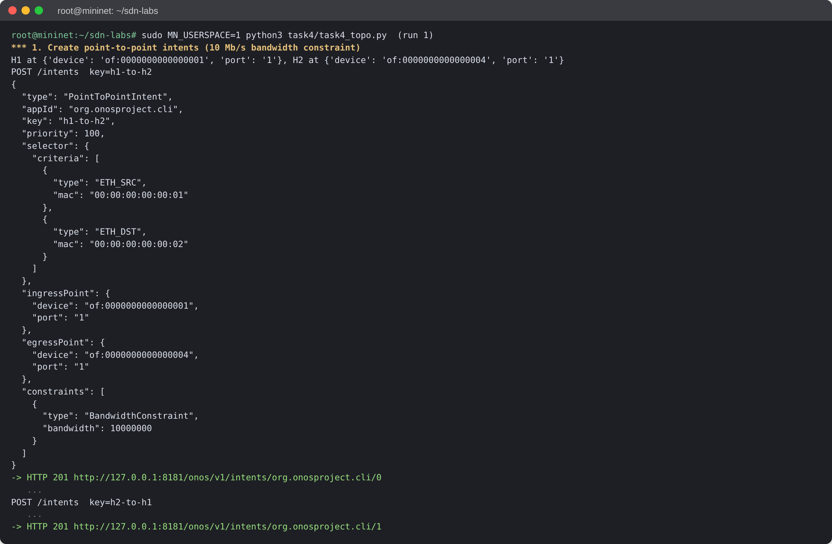
Figure 4.1: Run 1: PointToPointIntent payloads with BandwidthConstraint, created with HTTP 201
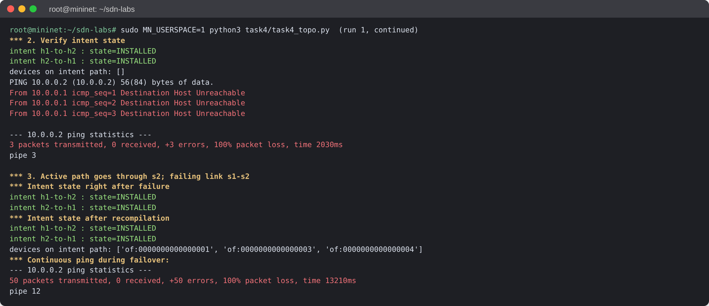
Figure 4.2: Run 1: intents INSTALLED, link s1–s2 failed, ONOS recompiled the path onto s1–s3–s4
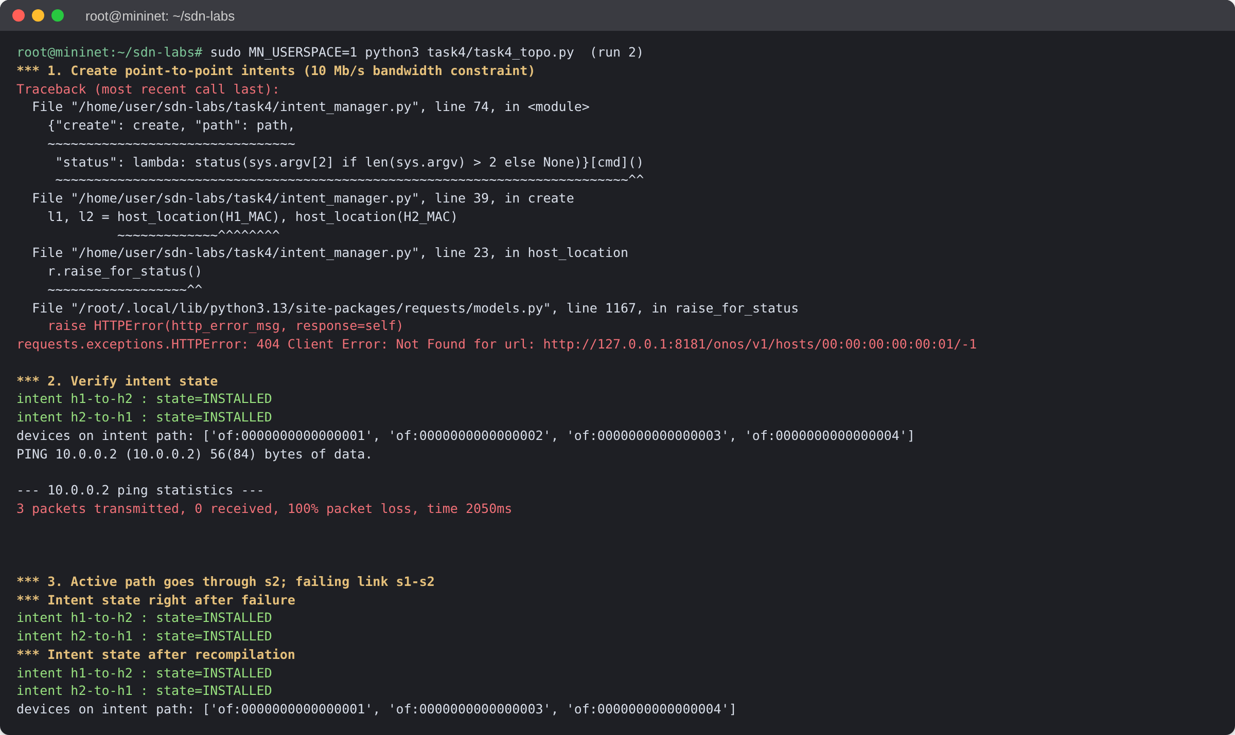
Figure 4.3: Run 2: intent creation failed (hosts not discovered, HTTP 404); states shown are the run 1 intents

Result and known issues
- Run 1 created both intents with a 10 Mb/s bandwidth constraint (HTTP 201), and they reached INSTALLED.
- After link s1–s2 went down, ONOS recompiled the intents onto s1→s3→s4, which shows automatic rerouting in the control plane.
- Data plane not verified: pings failed in both runs, so this report does not show traffic surviving the failover. Run 1 failed on ARP ("Destination Host Unreachable"): the intents carry only H1↔H2 unicast, and the fwd app was off.
- Run 2: with static ARP added, ONOS no longer discovered the hosts (HTTP 404), so no new intents were created. A flow-table dump in a separate debug run showed the intent rules were correct but never matched any packets. Task 1's ICMP drop rules for 10.0.0.1↔10.0.0.2 were still installed at priority 40000. The 4 rules were not deleted and the run was not repeated.
- To complete: delete the leftover Task 1 flows (DELETE /flows/<device>/<id>), give hosts static ARP and still let ONOS discover them (for example with a gratuitous ping while fwd is on, before turning it off), then rerun task4_topo.py.

